Beyond Bodel / Au-delà de Bodel

Gattung und Textgemeinschaften in der handschriftlichen Überlieferung französischer und deutscher Ritterromane

Elisabeth de Bruijn and Mike Kestemont

Introduction

Over the past decades, medieval studies have increasingly turned their attention to the material contexts in which medieval texts were transmitted. Whereas modern editions generally present medieval works as self-contained texts, for their original audiences they were often part of larger, multi-text manuscripts. This shift in perspective from text to codex has far-reaching consequences for our understanding of reception and genre formation. When texts are repeatedly transmitted together, this is not necessarily the result of chance: the composition of multi-text manuscripts may reflect particular contexts of use and compilatory opportunities and decisions, thus offering a unique window onto the ways in which texts were understood and related to one another in the past. In this sense, co-transmission may be understood as a material reflection of intertextuality. Manuscript compilation places texts in relation to one another without requiring explicit textual reference, creating constellations in which literary and generic associations can emerge from material proximity.

Perhaps nowhere is this fundamental difference between medieval and modern textual culture more apparent than in chivalric romance, a genre that flourished in the Middle Ages and subsequently enjoyed an exceptionally long reception history. Narratives about Arthur, Charlemagne, Tristan, or Floire and Blancheflor circulated for centuries in manuscripts and printed books, and survived into modern adaptations, from T. H. White’s The Once and Future King (1958) to Disney’s The Sword in the Stone (1963). Yet this enduring popularity has also encouraged a particular mode of reading. Chivalric romances are now commonly, and likely: anachronistically, approached as individual works or as representatives of a clearly defined genre. Medieval audiences, however, often encountered romances as part of larger textual constellations, in which individual works stood in material proximity to other narratives. Such manuscript contexts raise the question of whether works that we regard as belonging together in literary-historical terms were also brought together in medieval transmission. This question is particularly pertinent to chivalric romance, a broad and varied body of narratives that circulated widely across European vernaculars from the twelfth century onwards. Medieval classifications already sought to articulate distinctions within this material; the most famous example of such an attempt is probably Jean Bodel’s division of the contemporary narratives he knew into the matières of France, Britain, and Rome. The present contribution takes Bodel’s scheme as a point of departure to ask to what extent established literary categories correspond to patterns of co-transmission in medieval manuscripts.

Only recently have research infrastructures become available that allow such patterns of co-transmission to be investigated systematically and comparatively. The data used here build on the corpus compiled for the Science article ‘Forgotten Books’ (Kestemont et al. 2022), which suggested substantial differences in the survival of chivalric literature across six European vernaculars. This corpus is currently being expanded through a collaboration between the École nationale des chartes in Paris (ERC project LostMA) and the University of Antwerp, with the aim of documenting as comprehensively as possible the surviving manuscript transmission of chivalric narrative across the European vernaculars included in the project. The resulting database uses romance as an umbrella term for narratives of chivalry, encompassing traditions such as the chansons de geste and German Heldendichtung. It records individual works and their manuscript witnesses alongside chronological and literary metadata. Although reconstructing every textual collection in which these works were transmitted would exceed the scope of a project of this size, the systematic recording of manuscripts and shelfmarks makes it possible, for the first time, to visualise patterns in the co-transmission of chivalric romances comparatively.

This contribution asks how chivalric romances were transmitted alongside one another. The primary objects of analysis are therefore not just the individual works, but the multi-text manuscripts in which they co-occur. These codicological constellations allow us to identify textual communities that emerge from patterns of co-transmission and to ask whether they correspond to established generic distinctions. Our focus is on French and German transmission, the two largest corpora in the LostMA database and two literary traditions closely connected through centuries of inter-vernacular exchange. Using quantitative network analysis, we examine the cohesion and composition of the textual communities found in each tradition. In particular, we ask to what extent patterns of co-transmission correspond to Bodel’s matières, and what aspects of manuscript transmission fall outside this classificatory framework.

1. French and German Chivalric Romances in Comparison

Before turning to the thematic organisation of manuscript transmission, it is useful to compare the basic structure of the French and German corpora. The two traditions differ substantially in size: after fragmentary witnesses are excluded, the French dataset comprises 256 works in 911 manuscripts, while the German corpus contains 118 works in 449 manuscripts. More important for the present analysis, however, is the way in which romances are distributed across manuscripts. French manuscripts bring several romances together considerably more often, whereas German transmission is more strongly characterised by manuscripts containing a single romance. This difference becomes particularly clear when we compare the number of romances per manuscript (Fig. 1A).
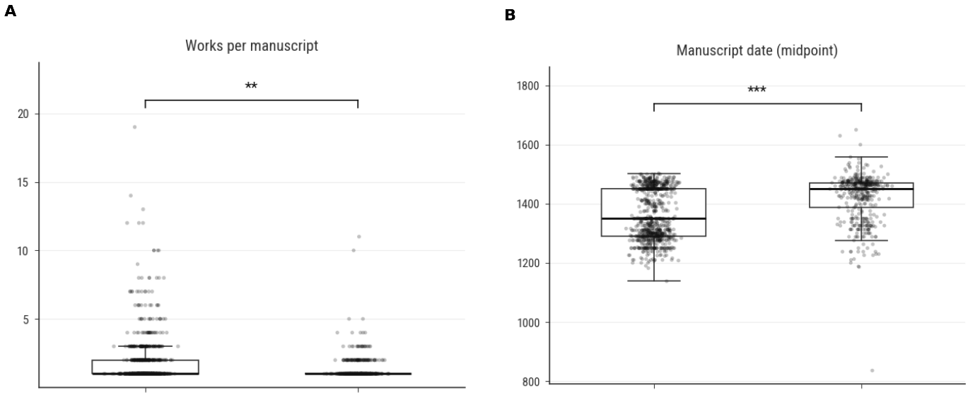
Fig. 1. Structural differences between French and German romance transmission: (A) number of works per manuscript; (B) manuscript date (midpoint).

French manuscripts contain an average of 1.77 romances, compared with 1.35 in the German corpus, and the difference between the two distributions is statistically significant (p = 0.00022). The contrast is also visible at the upper end of the distribution: while the largest German manuscript in the dataset contains eleven romances, the French corpus includes manuscripts containing up to nineteen. In both traditions single-romance manuscripts remain common, but French transmission has a substantially longer tail of manuscripts in which romances accumulate. French romances therefore have more opportunities to enter into repeated combinations with other works. Importantly, this contrast cannot simply be explained by a difference in the number of surviving witnesses per work. The mean number of attested witnesses per work is similar in the two corpora: 5.38 for French and 5.06 for German, and the distributions do not differ significantly. French romances are therefore not simply represented by more surviving witnesses and thus mechanically more likely to encounter other texts. What differs is the organisation of those witnesses into manuscript contexts.

A second structural difference concerns chronology. The works themselves belong broadly to the same period: their median dates of composition, around 1250 for French and 1265 for German, do not differ significantly. Their surviving manuscript witnesses, by contrast, do (Fig. 1B). The median manuscript date is approximately 1350 in the French corpus and 1450 in the German corpus, a highly significant difference. This later profile of German transmission should be kept in mind when interpreting the patterns below. It may reflect differences in the chronology of copying and collection formation, although chronology alone cannot explain why romances were grouped differently within individual codices. Having established these structural differences, we can now ask which kinds of romances were brought together, and whether the traditional matières help to explain these patterns.

2. The Distribution of Matières across the Two Traditions

A first step is to establish how the three matières are represented in the two corpora. We use the traditional distinction formulated by Jean Bodel around 1200: the matière de Bretagne, comprising narratives associated with Arthur and the British world; the matière de France, centred primarily on Charlemagne and the heroic world of the chansons de geste; and the matière de Rome, encompassing narratives concerned with classical antiquity. Works that fall outside these three categories are grouped here as Other. The distributions differ considerably between the French and German corpora (Fig. 2).

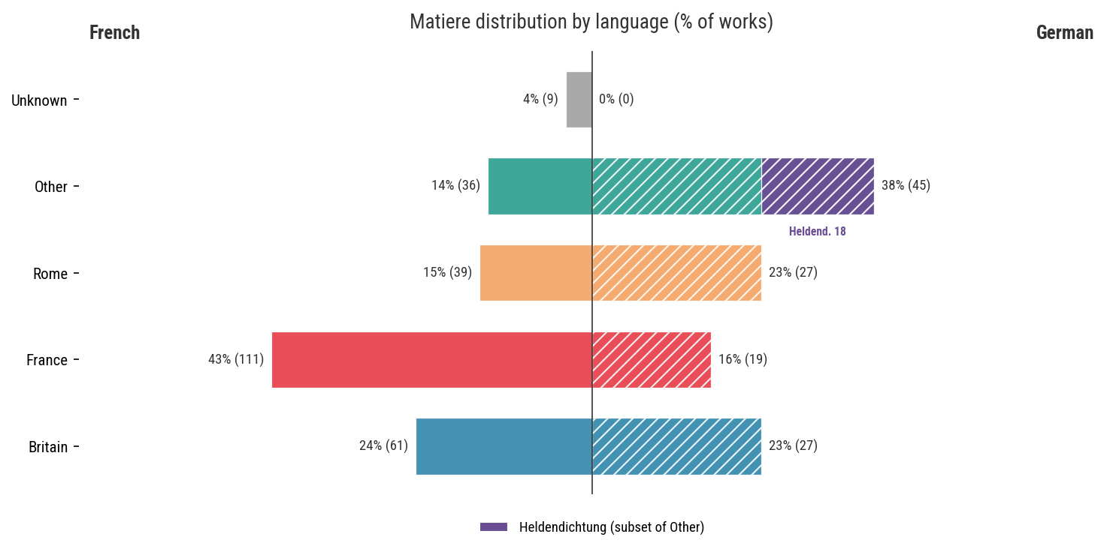
Fig. 2 Share of works assigned to each matière. Checken: klopt het aantal heldendichten? In Excel nog 22?

In the French corpus, Bodel’s categories account for a substantial proportion of the material. The matière de France is particularly prominent, reflecting the large body of chansons de geste, while the matière de Bretagne likewise constitutes a sizeable part of the corpus. The German distribution is markedly different, most notably in the much larger proportion of works classified as Other. This category should not, however, be understood simply as a heterogeneous residue of texts that resist meaningful classification. It includes, most importantly, German Heldendichtung, one of the most distinctive narrative traditions in the German corpus. The prominence of Other therefore exposes a fundamental asymmetry in applying Bodel’s scheme comparatively: the three matières encompass a substantially larger proportion of the French than of the German corpus. This difference in coverage does not necessarily imply that Bodel’s categories structure German co-transmission less strongly where they do apply.

This asymmetry is important for the network analyses that follow. If works belonging to the same matière tend to be transmitted together, this would suggest that Bodel’s categories correspond, at least to some extent, to patterns of medieval manuscript transmission. The unequal coverage of the two corpora must, however, be kept in mind: the large category Other may conceal coherent textual communities for which Bodel’s model simply has no name. Bodel’s scheme thus serves here not as a neutral taxonomy but as a historical hypothesis to be tested against manuscript transmission. Do works assigned to the same matière actually occur together, and does Bodel’s scheme have the same explanatory power in the two traditions? To answer these questions, we now move from the overall distributions shown in Fig. 2 to the manuscript combinations themselves.

3. Matière and Textual Communities in the Co-transmission Networks

Figure 3 visualises the co-transmission networks for works assigned to the three Bodelian matières. Works classified as Other, as well as works whose matière is unknown, are excluded at this stage, allowing us to compare directly how Bodel’s categories structure those parts of the French and German corpora to which they can be applied. In both networks, two works are connected when they occur together in at least one manuscript, while node colour indicates matière. In both networks, works belonging to the same matière show a visible tendency to cluster together, although neither network resolves into three discrete communities. Bodel’s categories thus appear to structure co-transmission without determining it completely.
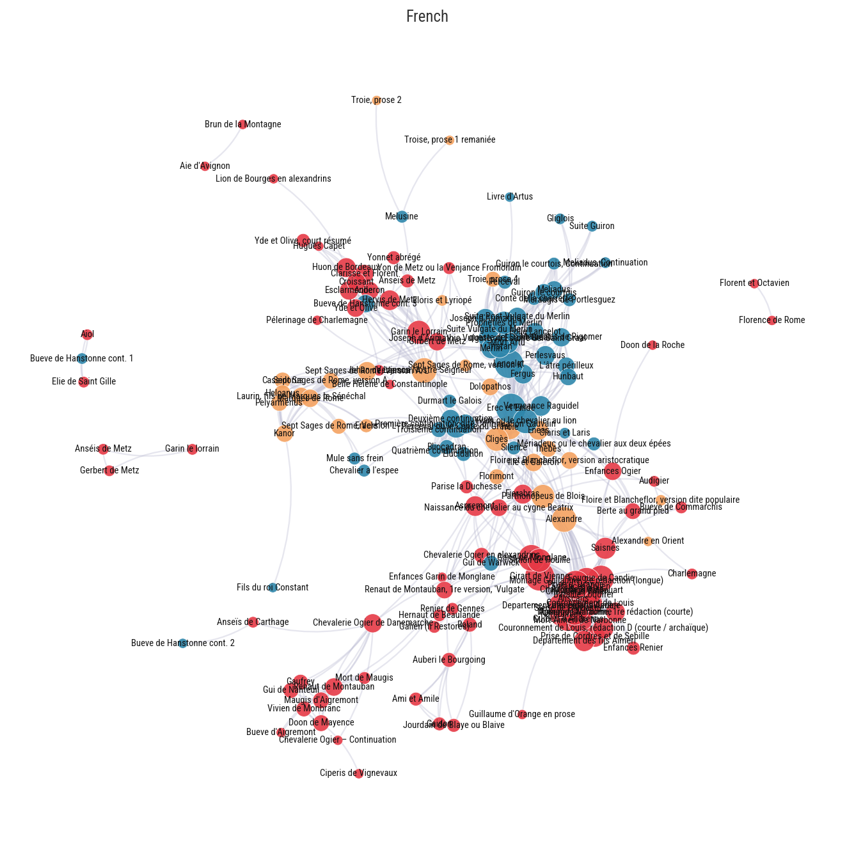
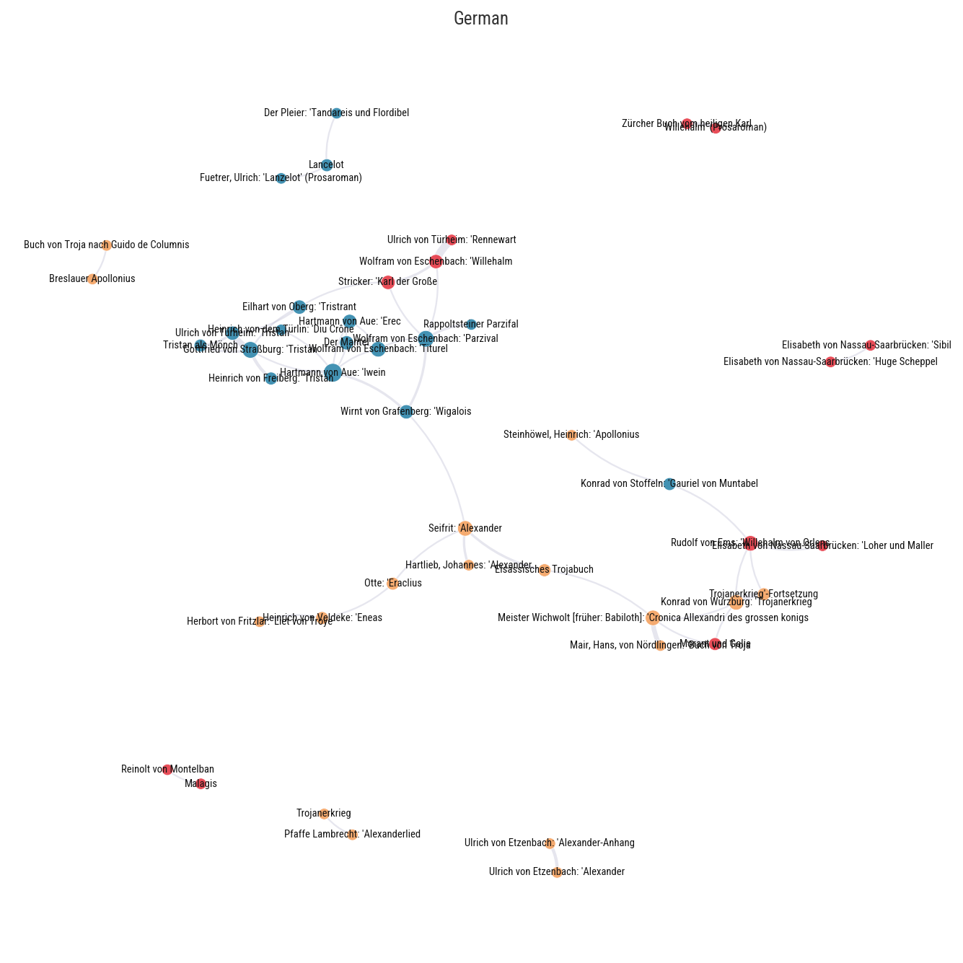
Fig. 3 Node-labelled version of the restricted network for each tradition, enabling identification of individual works.

This visual impression is borne out by the quantitative comparison of matière homophily. In both traditions, co-transmission links remain within the same matière far more often than would be expected by chance: 91.1% of weighted links in the French network (39.0% expected under random permutation) and 88.2% in the German network (33.6% expected), with permutation tests yielding p = .001 in both cases. Overall assortativity is also almost identical in the two traditions (.677 for French and .673 for German). Beneath this similarity, however, the individual matières behave differently: matière-specific homophily is particularly high for France in the French corpus (.951), but lower for the same matière in the German corpus (.800), whereas Rome shows the reverse pattern (.701 in French versus .893 in German). Consistent with these differences, a model allowing the effect of matière to vary by language provides a better description of the data than one assuming a uniform pattern across the two traditions.

These results require an important qualification. Figure 3 tests the explanatory power of Bodel’s categories only after works classified as Other have been removed. It therefore shows that the three matières strongly structure co-transmission where they apply, not that they provide an equally comprehensive account of French and German transmission as a whole. As Fig. 2 has already shown, this distinction matters particularly for German, where Other encompasses a substantial part of the corpus. The next step is therefore to restore this excluded material and ask whether it is genuinely residual, or whether it contains coherent textual communities obscured by the Bodelian classification.

4. Beyond Bodel: Heldendichtung and the German ‘Other’

The restricted networks in Fig. 3 demonstrate that Bodel’s matières strongly structure co-transmission in both traditions. This comparison, however, excludes a much larger proportion of the German corpus than of the French. Figure 4 therefore restores the works previously excluded from the comparison. In the German network, Heldendichtung is distinguished from the remaining Other works in order to test whether this historically recognised narrative tradition, for which Bodel’s scheme has no category, also forms a coherent community in manuscript transmission.
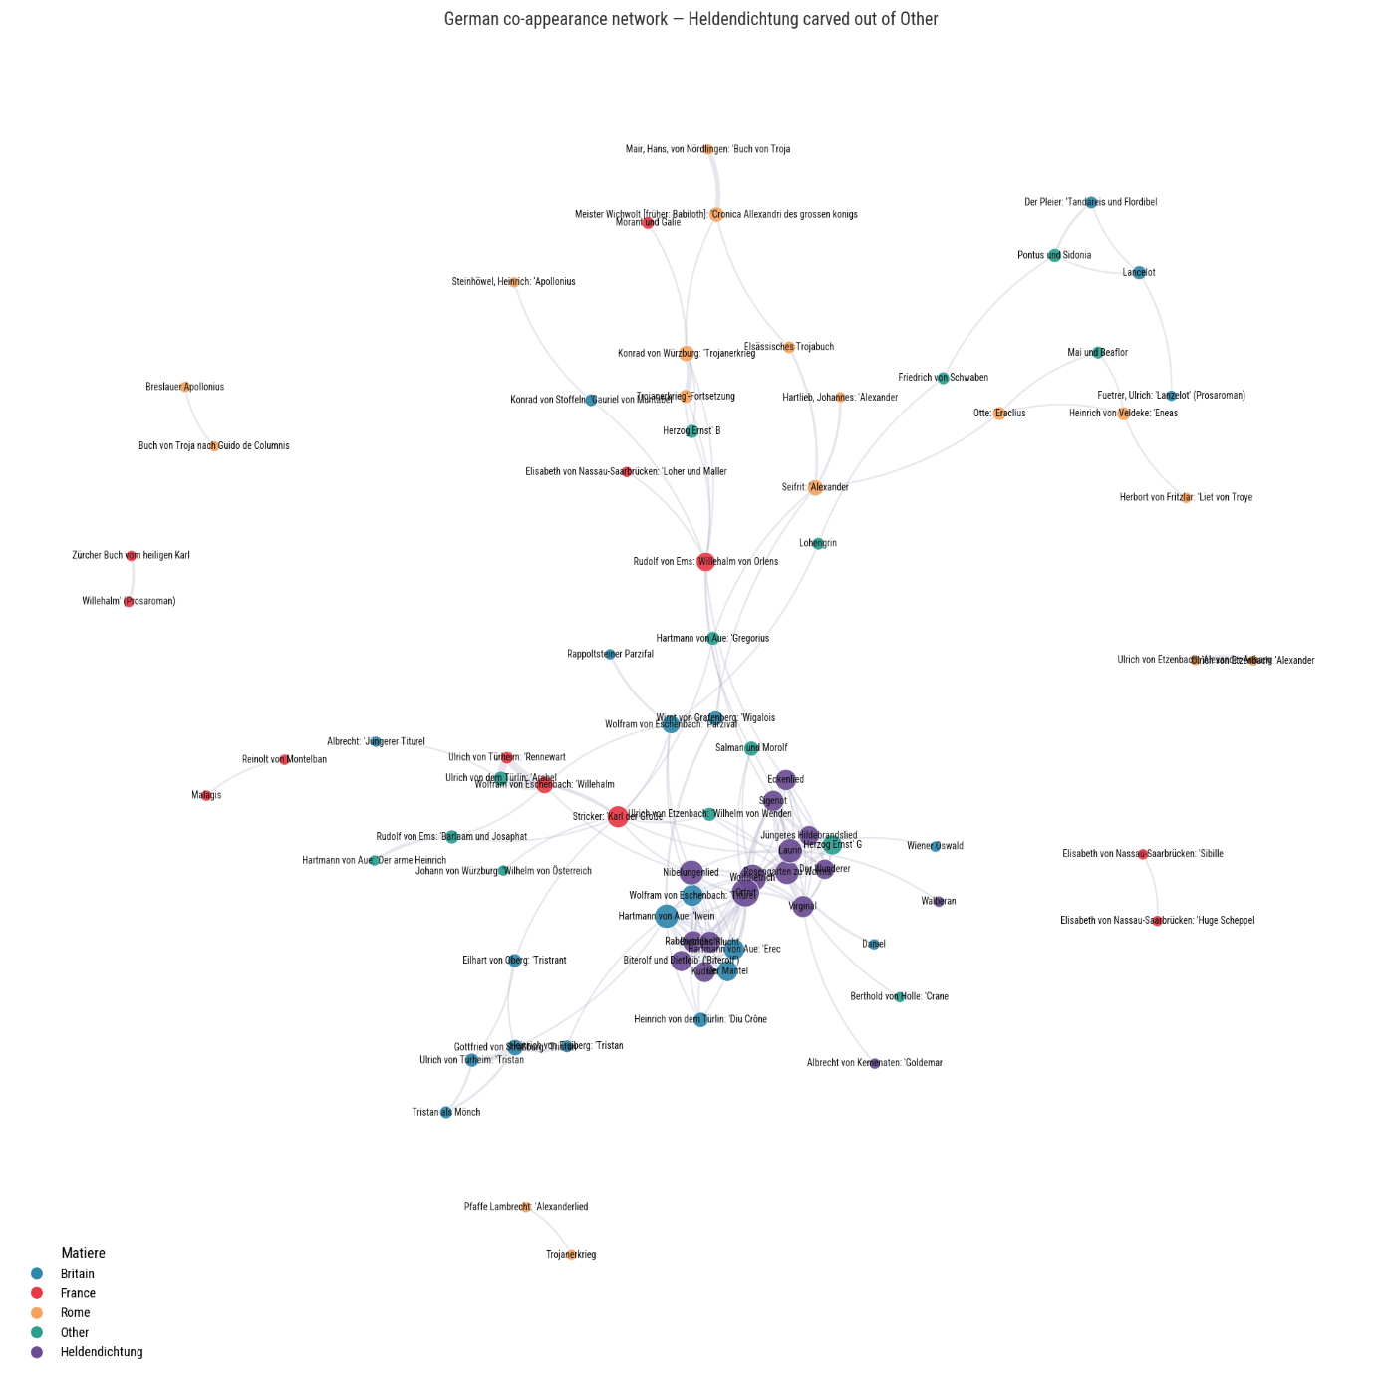

Mike, kun je zo’n zelfde visualisatie toevoegen voor het Frans? [CHECK: exact criteria and works included]. Hier nog geen Dietrich-subclusters. Dat analyseniveau bewaren we voor §5

Fig. 4. Complete French and German co-transmission networks, including Other. In the German network, Heldendichtung is distinguished from the remaining Other.

The result is revealing. Once Heldendichtung is distinguished from Other, its coherence as a narrative tradition is also reflected in the German co-transmission network. This does not imply that Heldendichtung forms a homogeneous textual community. Like Bodel’s individual matières, it contains further internal differentiation, but such substructures lie beyond the level of comparison pursued here and will be considered separately in §5. The quantitative results point in the same direction [CHECK ALL FOLLOWING VALUES AGAINST FINAL NOTEBOOK]. The point is not that adding Heldendichtung produces a universally better taxonomy. Rather, the experiment demonstrates that Other need not be residual in any meaningful literary sense: it may contain coherent traditions simply because the classificatory scheme lacks a category for them.

The comparison between the two traditions can therefore be formulated more precisely. The strong matière homophily observed in §3 shows that Bodel’s categories correspond remarkably well to patterns of co-transmission in both French and German where they apply. Their limitation lies not primarily in their explanatory power, but in their coverage: they do not provide an exhaustive vocabulary for the narrative traditions encountered across vernacular literatures. German Heldendichtung provides a particularly clear example. The analyses so far, however, have started from established literary categories and tested them against manuscript transmission. What happens if we reverse the procedure and allow textual communities to emerge from the networks themselves?

5. From Categories to Communities

Rather than assigning works to categories in advance, we now allow communities to emerge from the networks themselves and subsequently ask how these data-driven groupings relate to established literary traditions. This reverses the perspective of the preceding analyses and shifts attention from broad classificatory categories to the smaller textual constellations that underlie them.
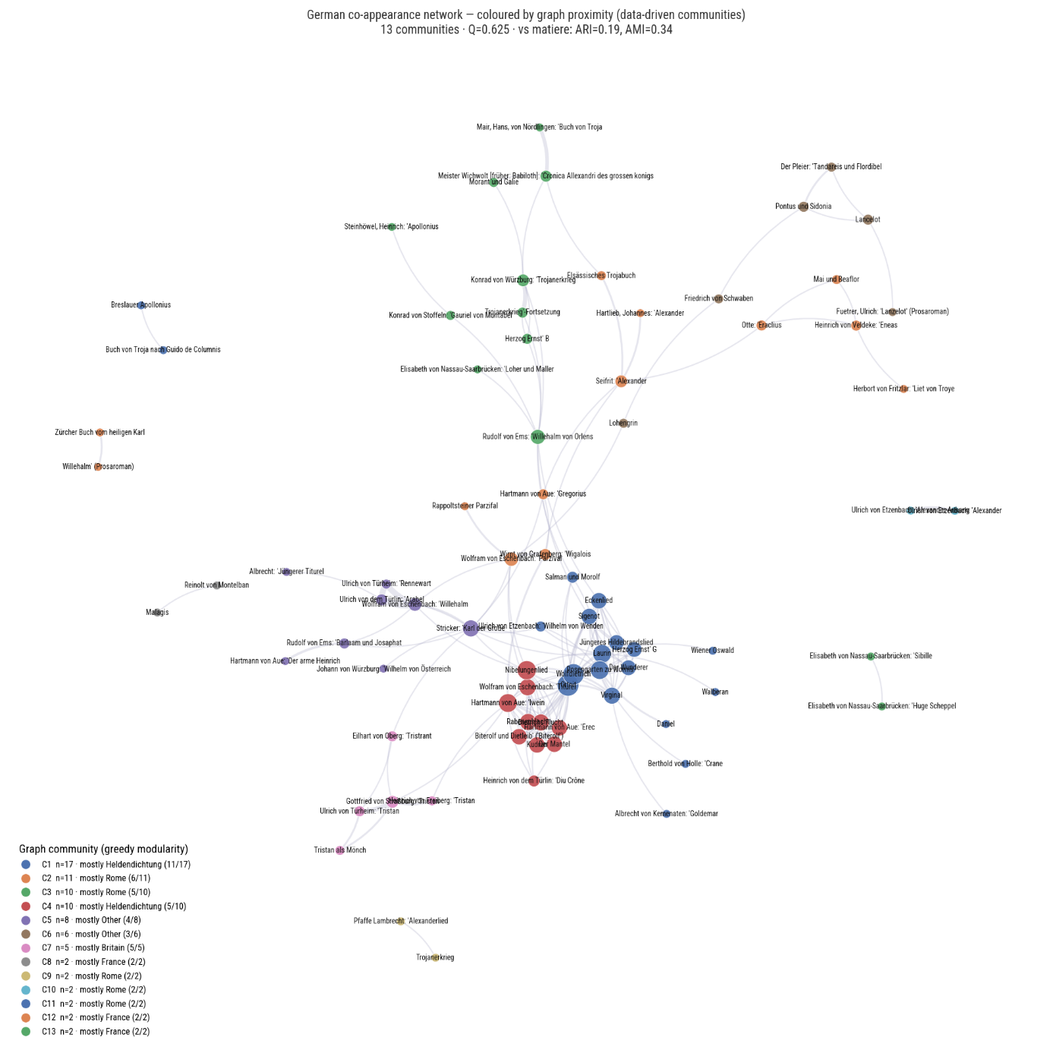

Fig. 5 A and B. Data-driven communities in the French and German co-transmission networks.
(Ook zo’n afbeelding voor Frans toevoegen)

The French network shows particularly clearly how the broad affinities captured by Bodel’s matières subdivide into more specific textual communities. Within the matière de France, the Guillaume d’Orange tradition forms a densely interconnected group. Works associated with the Geste de Doon de Mayence form another recognisable constellation, while a further epic grouping is centred on Lorraine and Burgundy. Comparable internal differentiation appears in the matière de Bretagne: the prose Lancelot-Grail material clusters separately from Chrétien de Troyes’s verse romances, which are embedded in a more mixed network of verse narratives. At the level of individual connections, the latter repeatedly co-occur with romances of antiquity. The Roman de Troie, in particular, is an important co-transmission partner for Erec, Cligès, and Yvain in the present corpus. These patterns reveal a different scale of organisation from the matière homophily established in §3. Bodel’s categories capture broad affinities in manuscript transmission, while the bottom-up communities differentiate more specific constellations within them and expose local connections across their boundaries. The bottom-up perspective thus refines rather than overturns the picture obtained from Bodel’s categories.

The German bottom-up communities show a comparable process of differentiation, but not a simple mirror image of the French network. Heldendichtung, which emerged in §4 as a meaningful category concealed within Other, is concentrated especially in two of the larger detected communities rather than forming a single undifferentiated block. Within this heroic material, the Dietrich texts separate into two constellations that largely correspond to the traditional distinction between the adventure-oriented aventiurehafte Dietrichepik and the historically oriented narratives of exile and return (historische Dietrichepik). This is particularly noteworthy because these communities were detected solely on the basis of co-transmission: a distinction familiar from literary history is thus also reflected in manuscript practice. The correspondence is not absolute, however. Works such as Wolfdietrich and Ortnit [checken of dat nog steeds zo is in de nieuwste visualisaties] occupy positions connecting different parts of the heroic network, showing that the boundaries between these communities remain permeable. Other constellations are also recognisable. The Tristan material forms a relatively compact constellation, while Willehalm and related texts likewise show a marked tendency to cluster together.

The bottom-up analysis thus both confirms and complicates the picture developed in the preceding sections. The detected communities do not map mechanically onto established literary classifications: some correspond closely to recognised traditions, while others reveal affinities that cut across the broader categories used above. The distinction is therefore not between literary classification and manuscript practice, but between different scales of organisation. Manuscript transmission can reproduce broad generic affinities while simultaneously articulating more local relationships between works.

Conclusion

The comparative analysis of French and German romance transmission reveals both the explanatory power and the limitations of established literary classifications. Bodel’s matières are not merely literary-historical categories: where they apply, they correspond strikingly well to patterns of manuscript co-transmission in both traditions. The high levels of matière homophily found in the French and German networks show that broad thematic affinities are strongly reflected in the ways romances were brought together in manuscripts. At the same time, the comparison exposes an important distinction between explanatory power and coverage. Bodel’s scheme encompasses a substantially larger proportion of the French corpus than of the German. The German category Other does not simply consist of classificatory noise: once Heldendichtung is distinguished within it, its coherence as a narrative tradition is also reflected in manuscript co-transmission. A classificatory system may therefore correspond closely to manuscript practice within its domain without providing an exhaustive vocabulary for comparison across vernacular traditions.

The bottom-up analysis adds a further level to this picture. Neither Bodel’s matières nor Heldendichtung constitute internally homogeneous textual communities. Within these broad categories, manuscript co-transmission differentiates smaller constellations, some of which also extend across their boundaries. Genre in manuscript transmission therefore appears not as a fixed set of mutually exclusive categories, but as a layered structure in which broad literary affinities coexist with more specific textual relationships. Co-transmission thus offers a way of approaching medieval genre not by choosing between historical categories and manuscript practice, but by examining the different scales at which the two intersect.

For important studies of multi-text manuscripts, see Stephen G. Nichols/Siegfried Wenzel (eds.): The Whole Book. Cultural Perspectives on the Medieval Miscellany. Ann Arbor 1996; Keith Busby: Codex and Context. Reading Old French Verse Narrative in Manuscript. Amsterdam/New York 2002, 2 vol.; Karen Pratt/Bart Besamusca/Matthias Meyer/Ad Putter (eds.): The Dynamics of the Medieval Manuscript. Text Collections from a European Perspective. Göttingen 2017.
Cf. Patrick Andrist/Paul Canart/Marilena Maniaci: La syntaxe du codex. Essai de codicologie structurale. Turnhout 2013; Jürgen Wolf: “Sammelhandschriften – mehr als die Summe der Einzelteile”. In: Dorothea Klein (ed.): Überlieferungsgeschichte transdisziplinär. Neue Perspektiven auf ein germanistisches Forschungsparadigma. Wiesbaden 2016, pp. 69-82.
On romances in multi-text manuscripts, see, for example, Miriam Edlich-Muth (ed.): Der Kurzroman in den spätmittelalterlichen Sammelhandschriften Europas / Pan-European Romances in Medieval Compilation Manuscripts. Wiesbaden 2018. [dit moet ik opzoeken]
For the working definition of romance adopted here and the criteria for inclusion in the corpus, see: [Mike, kun jij hier aanvullen hoe het best verwijzen naar datasets?]
Preservation status differs significantly between the French and German corpora (χ² = 362.36, df = 4, p < .001), most notably because fragmentary manuscripts are considerably more frequent in the German corpus (63% vs. 29%). This should be kept in mind as a potential source of bias, since fragmentary manuscripts may originally have contained additional romances. Mike, checken. Chatgpt adiviseert “methodologisch moet dit worden opgehelderd: de hoofdnetwerkanalyse sluit “Fragmentary” expliciet uit, terwijl deze statusfiguur de raw, ongefilterde data gebruikt.
Für eine moderne französische Übersetzung dieses Textes siehe Jean Bodel: La chanson des Saxons. Traduction en français moderne par Annette Brasseur. Paris 1992.
Three binomial models were compared: an intercept-only model, an additive matière + language model, and an interaction (matière × language) model. The interaction model showed the best predictive performance (ELPD = −490, compared with −500 for the additive and −600 for the null model). Since individual co-transmission links contribute to the observations of both connected works, these models are used descriptively rather than as independent significance tests; statistical significance is assessed through the permutation tests reported above.

